Building a mobile robot
série de 19 vidéo

1- Install template et git

2- Creating a rought 3D model of our robot with URDF
https://www.youtube.com/watch?v=BcjHyhV0kIs&list=PLunhqkrRNRhYAffV8JDiFOatQXuU-NnxT&index=2

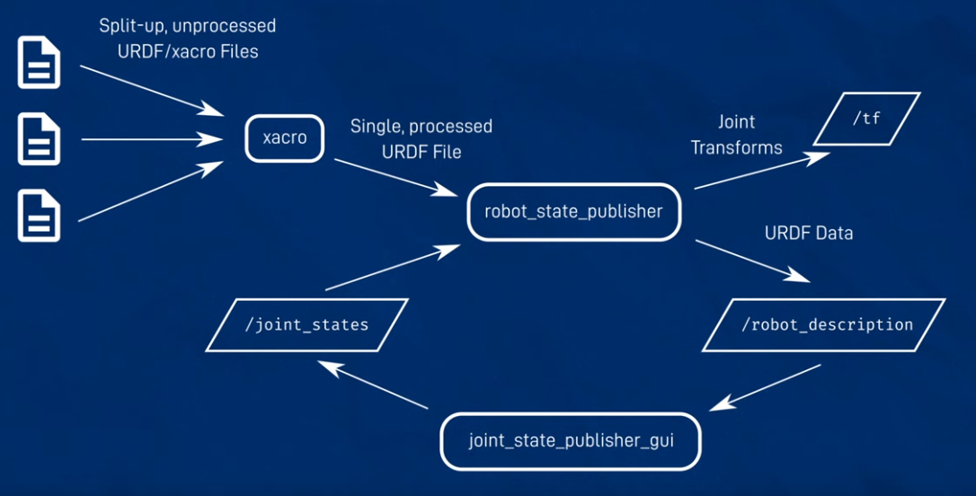
Pour installer Xacro

sudo apt install ros-foxy-xacro
sudo apt install ros-humble-xacro
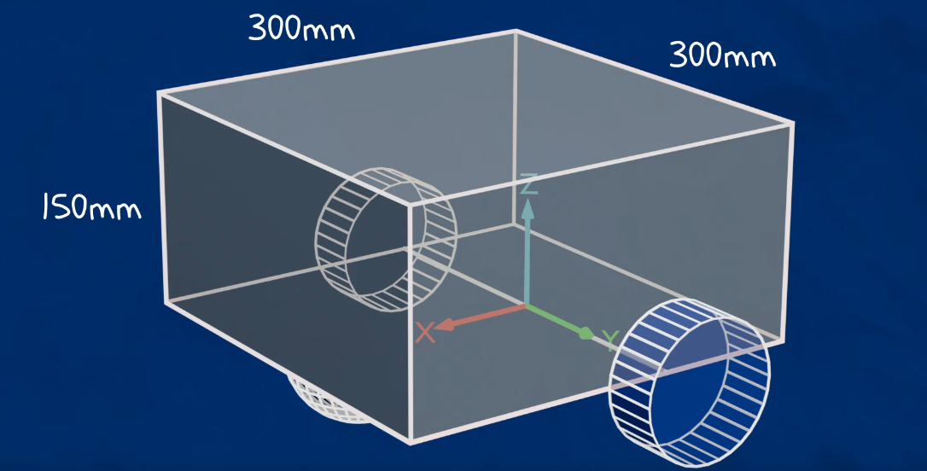
git status
git add .
git commit -m « message »
git push

commande pour démarrer joint state publisher gui
ros2 run joint_state_publisher_gui joint_state_publisher_gui

Vidéo3
https://www.youtube.com/watch?v=IjFcr5r0nMs&list=PLunhqkrRNRhYAffV8JDiFOatQXuU-NnxT&index=3

1- launch robot_state_publihser in sim mode
2- launch gazebo with ros compatilbity
3- spawn robot in gazebo with spawn scrip

tout ca avec un launch file

ros2 run teleop_twist_keyboard teleop_twist_keyboard

pour le joytick :
ros2 launch teleop_twist_joy teleop-launch.py

Notes : ***
les couleurs dans le xacro pour Gazebo doit etre majuscule la premiere lettre.

How to use Cameras in ROS (Sim Camera and Pi Camera)
https://www.youtube.com/watch?v=A3nw2M47K50&list=PLunhqkrRNRhYAffV8JDiFOatQXuU-NnxT&index=9

rgb camera

théorie :
Focal lenth
Horizontal FOV, field of view

drive node for the camera

topic is ‘sensor_msgs/Image’ and ‘ sensor_msgs/CompressedImage’

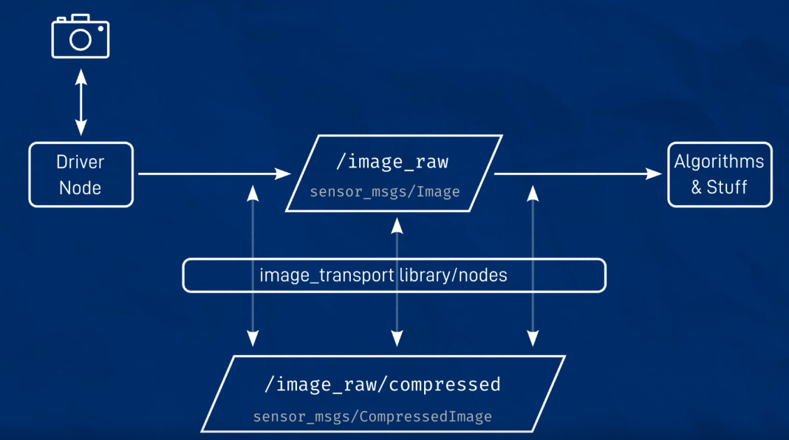

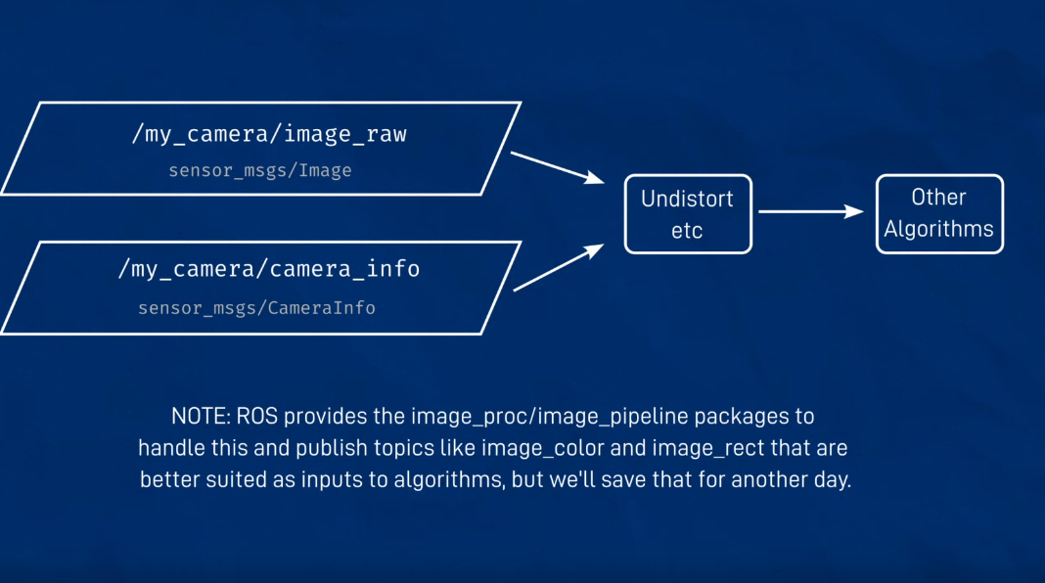

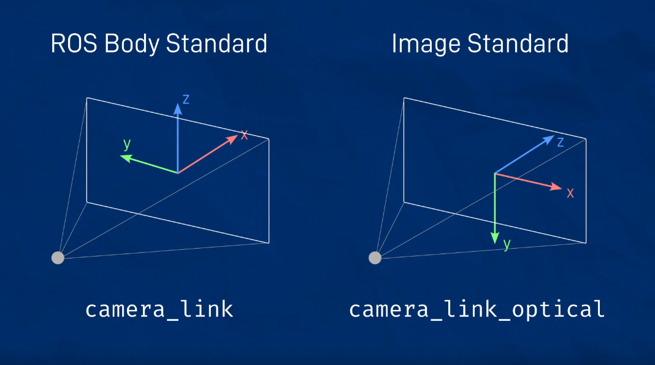

sudo apt install ros-humble-image-transport-plugins

sudo apt install ros-humble-rqt-image-view

Pour voir l’image compressed :
ros2 run rqt_image_view rqt_image_view
Pour démarrer le joystick :
ros2 launch teleop_twist_joy teleop-launch.py

----------------------------------------------------------------------------------------------------
Voir vers la fin du video pour voir comment faire
https://articulatedrobotics.xyz/mobile-robot-9-camera/

install vrai camera sur RPI

groups
vcgencmd get_camera
rasplistill-k

v4l2-ctl --list-devices

a installer
sudo apt install ros-humble-image-transport-plugins ros-humble-rqt-image-view

ros2 run v4l2_camera v4l2_camera_node --ros-args -p image_size:="[640,480]" -p camera_frame_id:=camera_optical_link

----------------------------------------------------------------------------------------------------

How to get your robot to see in 3D! (Depth Cameras in ROS)
https://www.youtube.com/watch?v=T9xZ22i9-Ys&list=PLunhqkrRNRhYAffV8JDiFOatQXuU-NnxT&index=10

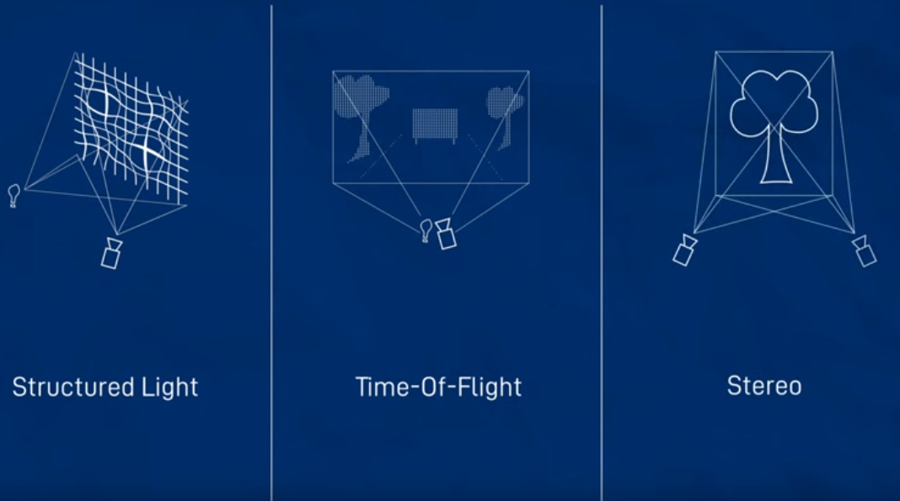

celui qu’il utilise pour vrai este le DepthAI (OAK-D)

marche pas bien a date

Designing a chassis for our robot! (+ other fixes)

https://www.youtube.com/watch?v=RjhBRn6lDSM&list=PLunhqkrRNRhYAffV8JDiFOatQXuU-NnxT&index=11

commande pour voir si le RPI est under voltage
vcgencmd get_throttled
si 0x0, c’est ok

--------------------------------------------------------------------
Probleme, le RPI envoi a tous les seconde un message car il n’est pas connecte a un écran?

Commande :
journalctl -fe

systemctl get-default
sudo systemctl set-default multi-use.target
reboot

--------------------------------------------------------------------

--------------------------------------------------------------------

How to get your robot to see in 3D! (Depth Cameras in ROS)
https://www.youtube.com/watch?v=T9xZ22i9-Ys&list=PLunhqkrRNRhYAffV8JDiFOatQXuU-NnxT&index=10

